Getting Started with Oracle Data Provider for .NET (C# Version)

Purpose
This tutorial describes how you can build a .NET application that uses the Oracle Data Provider for .NET to access data in an Oracle Database.

Time to Complete
Approximately 30 minutes

Topics
This tutorial covers the following topics:
Overview
Prerequisites
Creating a Project in Visual Studio
Adding a Reference
Retrieving Data from the Database
Incorporating Interactive Controls
Adding Error Handling
Retrieving Multiple Columns and Rows
Summary

Viewing Screenshots
Place the cursor over this icon to load and view all the screenshots for this tutorial. (Caution: This action loads all screenshots simultaneously, so response time may be slow depending on your Internet connection.)
Note: Alternatively, you can place the cursor over an individual icon in the following steps to load and view only the screenshot associated with that step. You can hide an individual screenshot by clicking it.

Overview
In addition to basic Oracle client connectivity software, .NET applications require the use of what is known as a managed data provider (where "managed" refers to code managed by the .NET framework). The data provider is the layer between the .NET application code and the Oracle client connectivity software.
The Oracle Data Provider for .NET (ODP.NET) is Oracle's high performance ADO.NET 2.0 compliant data provider that exposes a complete set of Oracle specific features and tuning options including support for Real Application Clusters, XML DB, and advanced security. It is available for free download from the Oracle Technology Network website.
When ODP.NET and any required Oracle client connectivity software is installed, application development using Visual Studio can begin. It is a good idea to confirm client connectivity before starting development. If you can connect to Oracle using SQL*Plus on the same machine as Visual Studio, then you know that your Oracle client-side software is properly installed and configured.
Back to Topic List

Prerequisites
Before you perform this tutorial, you should:
1. | Install Microsoft Visual Studio 2008
2. | Install Oracle Database 9.2 or later or Oracle Database XE
3. | Install Oracle 11g Oracle Data Access Components (ODAC) with Oracle Developer Tools for Visual Studio version 11.1.0.6.20 or later from OTN
Back to Topic List

Creating a Project in Visual Studio
To create a new project in Visual Studio, perform the following steps:
1. | From your Windows Program menu, start Visual Studio. From the File menu, select New Project.  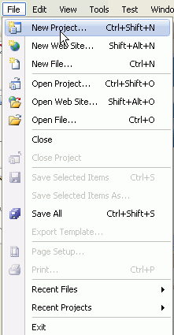  A New Project window appears.
2. | From the Project types list, select Visual C#: Windows. Select the Template Windows Form Application. In the Name field, enter OraWinApp. In the Location field, enter the directory where you want to save the files. (Note: if the directory does not exist, it is created). Click OK.  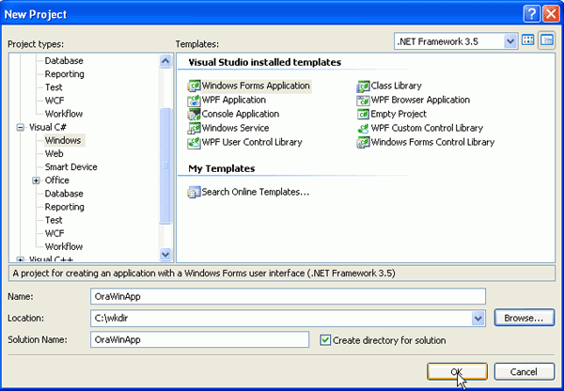
3. | The project has been created. From View menu, select Solution Explorer to open the Solution Explorer if not already open.  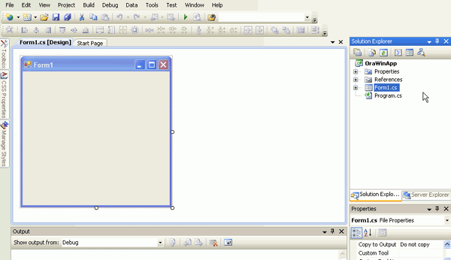
Back to Topic List

Adding a Reference
Because your project needs access to an Oracle database, it is necessary to add a reference to the dll containing the data provider. Perform the following steps:
1. | From Project menu, select Add Reference...  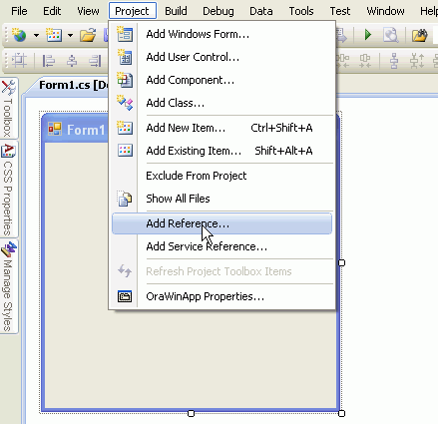  An Add Reference dialog box appears.
2. | Scroll down the list of Component Names and select Oracle.DataAccess. Click OK.  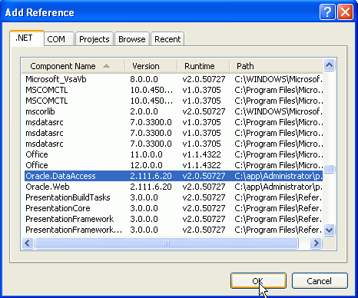
Back to Topic List

Retrieving Data from the Database
To retrieve data from the database, you can add some controls to your form. Perform the following steps:
1. | From View menu, select Toolbox. The toolbox appears. Expand Common Controls.  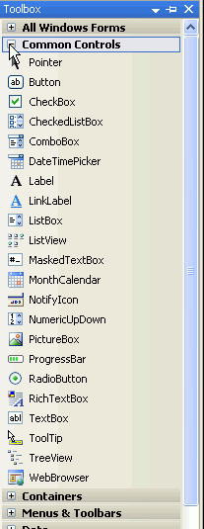
2. | Drag the Button control to the Form1 canvas.  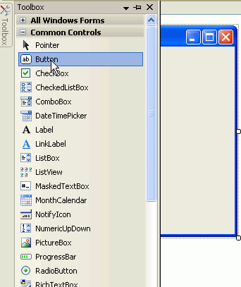  The control is shown on the canvas. You also need to create a Label.  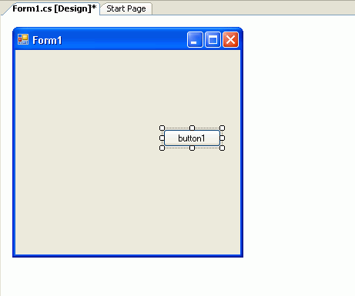
3. | From the Toolbox, drag the Label control to the Form1 canvas.  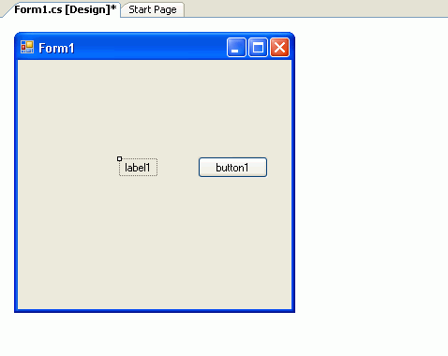
4. | Double-click button1 to open the code window. Note, Form1.cs code window opens.  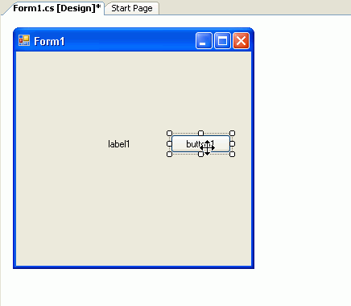
5. | Add the following C# using statements before the Public Class declaration.  using Oracle.DataAccess.Client; // ODP.NET Oracle managed provider  using Oracle.DataAccess.Types;  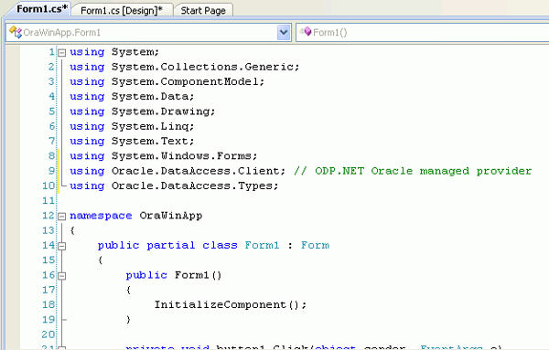
6. | Add the following C# code in between the private void button1_Click(object sender, EventArgs e)  { and } statements.  string oradb = "Data Source=ORCL;User Id=hr;Password=hr;";  OracleConnection conn = new OracleConnection(oradb); // C#  conn.Open();  OracleCommand cmd = new OracleCommand();  cmd.Connection = conn;  cmd.CommandText = "select department_name from departments where department_id = 10";  cmd.CommandType = CommandType.Text;  OracleDataReader dr = cmd.ExecuteReader();  dr.Read();  label1.Text = dr.GetString(0);  conn.Dispose();  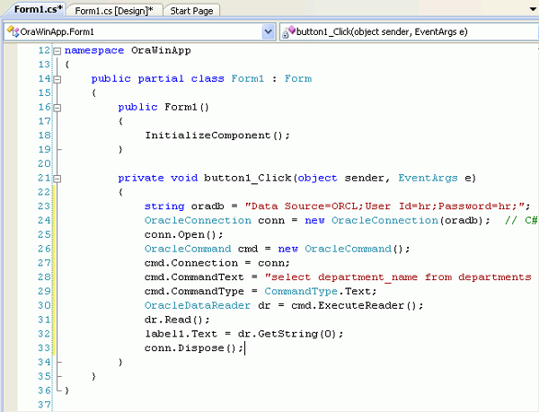
7. | Select Build > Build OraWinApp.  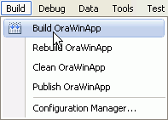  In the output window, ensure you did not get any errors. Now you can run the form.  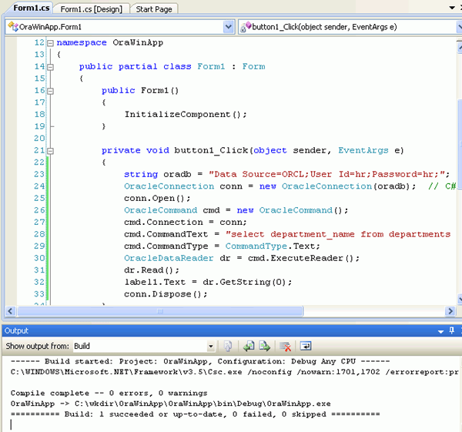
8. | Select Debug > Start Without Debugging.  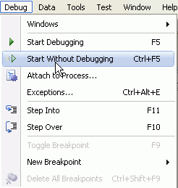
9. | The form appears. Click button1.  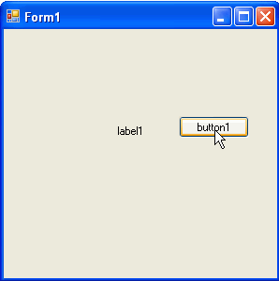  The result is shown in the label. Since the query in the code was to show the department name for department id of 10, the result is the Administration department. Close Form1.  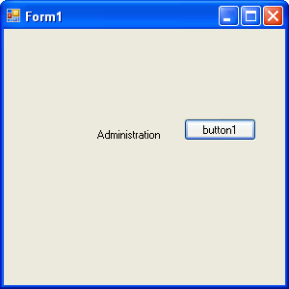
Back to Topic List

Incorporating Interactive Controls
Instead of running the hard coded query, you can add a textbox control to accept user input for the department id. Perform the following steps:
1. | Select the Form1.cs [Design] tab. From the Toolbox, drag the TextBox control to Form1 canvas.  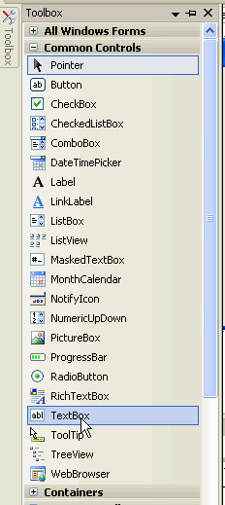  The textbox is shown. You can drag it to the desired location.  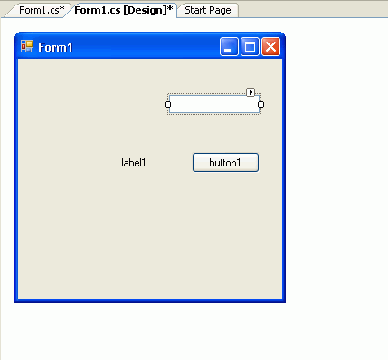
2. | Drag a Label control on Form1 canvas.  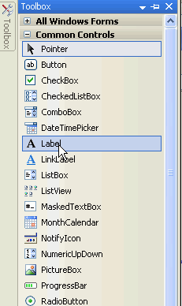
3. | The Label is shown. Right-click Label2 and select Properties.  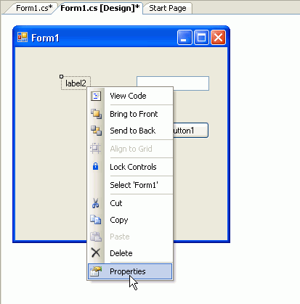
4. | In the Properties sheet, change the Text property to Enter Department ID:  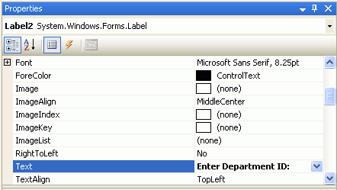
5. | Select the Form1.cs tab.  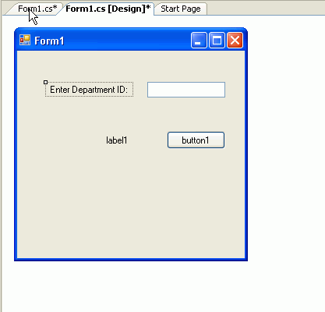
6. | You use a bind variable to include the value of the text box as part of the SELECT statement. Bind variables improve performance by preventing the database from having to reparse the SQL statement every time the text box value changes.  Add the following code right after the conn.Open() statement:  OracleParameter parm = new OracleParameter();  parm.OracleDbType = OracleDbType.Decimal;  parm.Value = textBox1.Text;  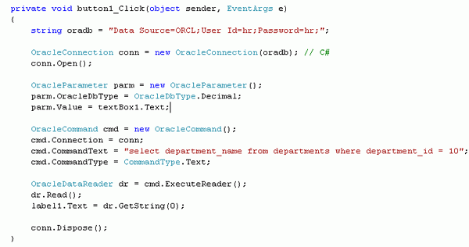
7. | Add the cmd.Parameters statement right after the cmd.Connection statement:  cmd.Parameters.Add(parm);  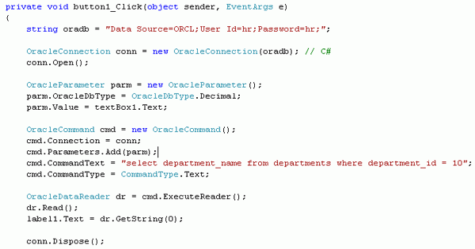
8. | Change the code for the cmd.CommandText statement to the following:  cmd.CommandText = "select department_name from departments where department_id = :1";  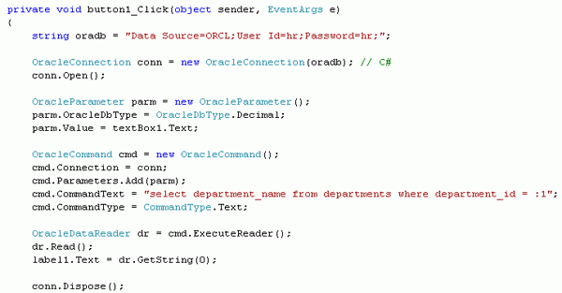
9. | Select Build > Rebuild OraWinApp.  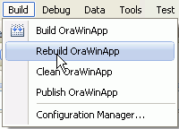  Check in the output window for any errors reported. If no errors or warnings, proceed with the next step.
10. | Select Debug > Start Without Debugging.  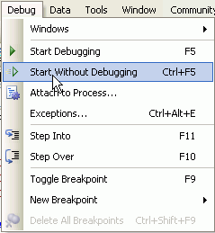
11. | Enter 20 for the Department ID and click button1.  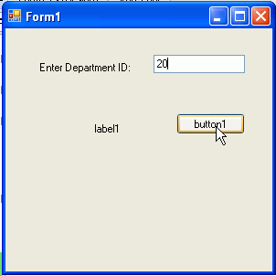
12. | Notice that the Label1 changes to the name of the department. This value depends on what is entered in the Department ID field.  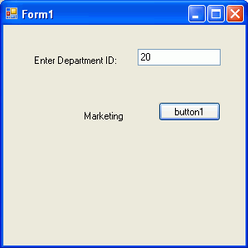
13. | Enter 300 for the Department ID and click button1.  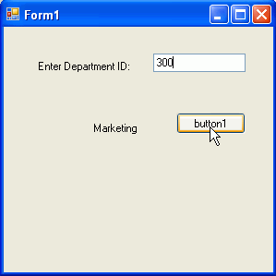
14. | This time you receive an error because there is no department with the id of 300. Click Quit. In the next topic you add some error handling so you know exactly why you received the error.  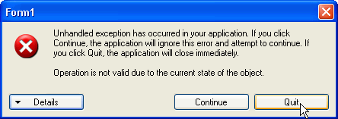
Back to Topic List

Adding Error Handling
Error handling is needed to instruct the user why something doesn't work properly. In this topic, you modify your code to prevent an error when an invalid Department ID is provided. In this tutorial, you add some very simple error handling code. For more robust error handling, Structured Exception Handling should be used. For more information on Structured Exception Handling with ODP.NET please refer to the ODP.NET online documentation. Perform the following steps:
1. | In Form1.cs window, change the following code from:  dr.Read();  label1.Text = dr.GetString(0);  to  if (dr.Read())  {  label1.Text = dr.GetString(0);  }  else  {  label1.Text = "Department ID not found";  };  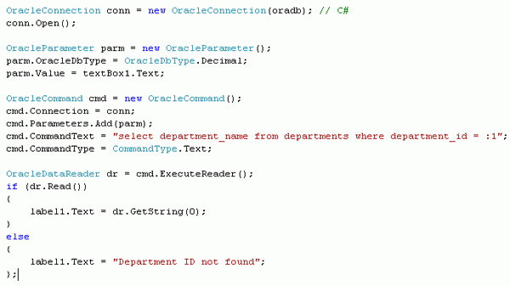
2. | Select Build > Rebuild OraWinApp. Ensure that there are no errors reported in the output window.  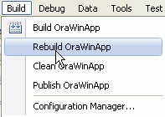
3. | Select Debug > Start Without Debugging.  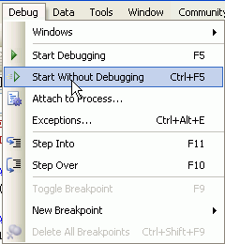
4. | Enter 300 again for the Department ID and click button1.  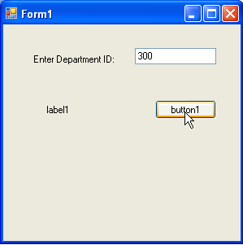
5. | This time, the message Department ID not found is displayed. Close Form1.  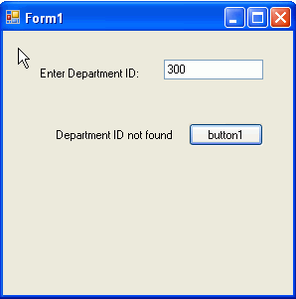
Back to Topic List

Retrieving Multiple Columns and Rows
In this topic, you want to retrieve more than one set of information using a listbox. Perform the following steps:
1. | Click the Form1.cs [Design] tab. From the Toolbox, drag the Listbox control to the Form 1 canvas.  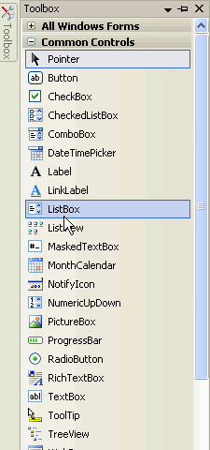
2. | The new listbox appears on the form. You can position and re-size the listbox appropriately. Click Form1.cs tab.  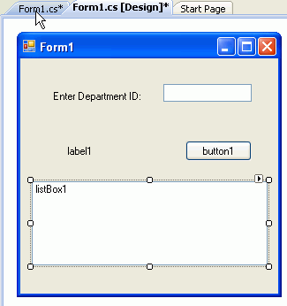
3. | Delete the cmd.Parameters.Add(parm); statement.  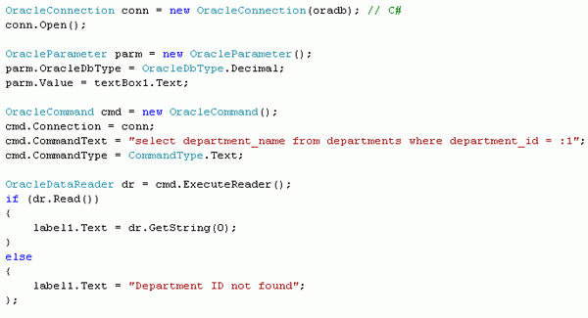
4. | Change the cmd.CommandText code from:  cmd.CommandText = "select department_name from departments where department_id = :1";  to  cmd.CommandText = "select department_id, department_name, city"  + " from departments d, locations l"  + " where d.location_id = l.location_id";  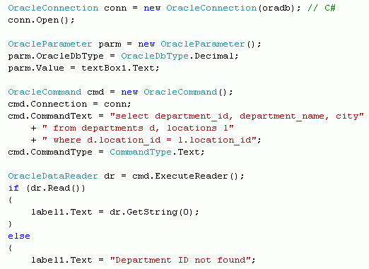
5. | Also change the following lines of code from:  if (dr.Read())  {  label1.Text = dr.GetString(0);  }  else  {  label1.Text = "Department ID not found";  };  to  while (dr.Read())  {  listBox1.Items.Add("The " + dr.GetString(1)  + " department is in " + dr.GetString(2));  }  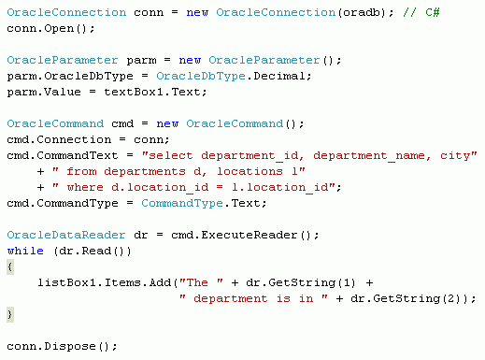
6. | Select Build > Rebuild OraWinApp.  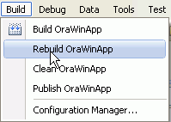
7. | Select Debug > Start Without Debugging.  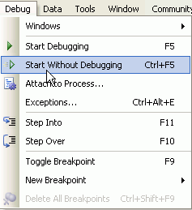
8. | Click button1.  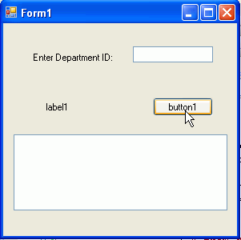
9. | The list of all the departments and their location is shown. Close Form1.  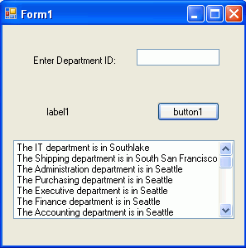
Back to Topic List

Summary
In this tutorial, you learned how to:
Create a project and add a reference
Retrieve data from the database
Incorporate interactive controls and error handling
Retrieve Multiple Columns and Rows
Back to Topic List

Move your mouse over this icon to hide all screenshots.

